Q1.

**Instructions:**

1. When you open the workspace, click "ACCEPT" in the lower-right corner of the REDHAT notification to enable import package suggestions while working on Selenium scripts.

2. Ensure that you do not make any changes to the existing main class file.

3. Common Maven Commands for Selenium:

· To change to a specific directory: cd /path of your maven project

· To run all test cases: mvn clean test

· To change to a parent directory: cd ..

4. To view the running scripts,

· Click on port 8081, and you'll be directed to a new window. In the URL bar of this new window, replace "8081" with "4444" to access the Selenium Grid.

· Perform the same procedure again, but replace "8081" with "7900" for VNC server page

· To view the execution, click on the "connect" button on the VNC server page and enter the password "secret".

5. If you need to terminate an active session in the Selenium Grid, you can click on the "reset grid" button located next to the "reload ide" button.

6. To execute your test scripts, click Run Test Case.

7. To submit your code, click "Submit Project" and to end the Test by clicking "Submit Test", where you find dialog box enter the text **"END"**.

**Note:**

If any pop-ups occurs, handle it by using Webdriver wait or reload the page.

**Problem statement:**

**Implement the Log4j with 7 levels of logs.**

Navigate to: [https://www.moneycontrol.com](https://www.moneycontrol.com/)

Test Steps:

1.Open your web browser and go to the Money control website.

2.On the top of the homepage, locate and click on the search box.

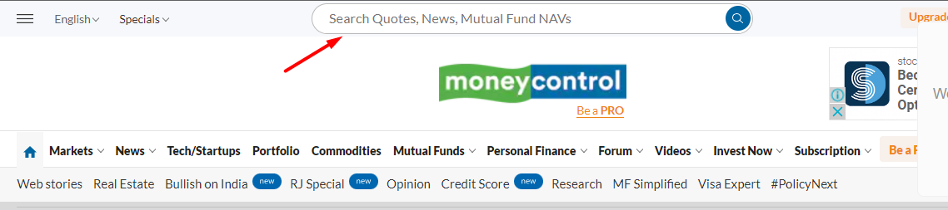

3.In the search-box , enter the data as "Reliance Industries."

4.Click on the primary suggestion in the displayed list, which will lead you to the chosen option .

5.Scroll down further and verify that the page contains the specific term "Reliance Industries Ltd."

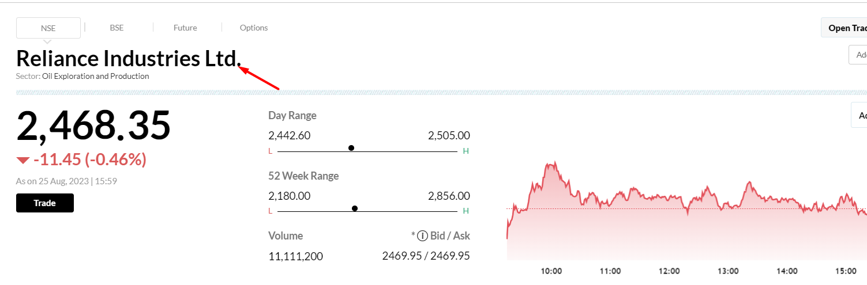

6.At the top navigation bar of the same page, click on the "Mutual Funds" dropdown and select the "SIP Return" option.

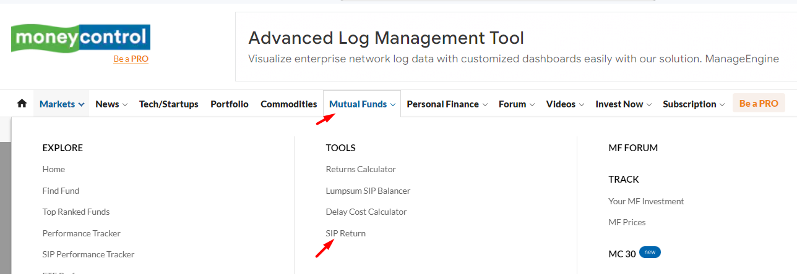

7.This action will redirect you to the SIP Calculator page. Here, choose the mutual fund named "**Axis Mutual Fund**" within the SIP calculator.

8.Choose for the mutual fund scheme as "**Axis Arbitrage Fund - Regular Plan (D**)."

9.Enter the investment amount as "**100,000"** Indian Rupees.

10.Set the SIP frequency to "**Monthly**."

11.Pick the start date as "**2021-08-02,**" and choose the end date as "**2023-08-17**" from the calendar.

12.Click on the "Calculate" button to proceed with the calculations.

13.Retrieve and display the investment period ("August 02, 2021 to August 17, 2023") from the first row, second data in the terminal.

Similarly, output the result of the "total amount invested" from the third row, second data in the terminal.